UR-SERV BUSINESS ADVISORY

FEASIBILITY STUDY REPORT
ATLANTIC HOSPITALITY HOTEL — NAIROBI, KENYA

Project Reference | ATL-KE-2026-FS
Prepared For | Investor / Financial Institution / Internal Decision-Making
Prepared By | Ur-Serv Business Advisory
Contact | Feasibility Studies Team –support@ur-serv.com
Region | Middle East & Africa (MEA)
Date | June 2026
Version | Indicative Sample v1.0 — Key Figures Partially Redacted

CONFIDENTIAL — For internal use by the intended recipient only. This document is a sample feasibility study prepared for planning and discussion purposes. Financial figures are indicative and partially redacted. This document does not constitute investment, legal, or financial advice.

TABLE OF CONTENTS
──────────────────────────────────────────────────────────────────────────────────────────────────────────────
0. Ur-Serv Scope of Work & Study Methodology
1. Executive Summary
2. Project Overview
3. Market Assessment
4. Technical & Operational Feasibility
5. Management & Organisational Structure
6. Financial Feasibility
7. Sensitivity Analysis
8. Financing & Capital Structure
9. Risk Assessment & Mitigation
10. Legal & Regulatory Framework
11. Environmental & Social Considerations
12. Conclusions & Recommendations
Appendices. List of Appendices

0. Ur-Serv Scope of Work & Study Methodology
──────────────────────────────────────────────────────────────────────────────────────────────────────────────
Ur-Serv Business Advisory is a Cairo-based advisory firm specialising in business development, feasibility studies, strategic planning, and supply chain solutions across the Middle East and Africa region.
This engagement was commissioned to conduct a structured, evidence-based screening of the Atlantic Hospitality Hotel project in Nairobi, Kenya, enabling investors and decision-makers to assess feasibility prior to committing to a full-scale investment.
Ur-Serv's feasibility framework follows a seven-pillar methodology: (1) Scope Definition, (2) Desk-Based Market Research, (3) Technical & Operational Review, (4) Management Structure Assessment, (5) Financial Modelling, (6) Risk Profile Identification, and (7) Recommendation & Roadmap.
Pillar | Activity | Deliverable
1 – Scope Definition | Agree boundaries, exclusions, and assumptions | Terms of Reference
2 – Market Research | Desk research, benchmarking, demand validation | Market summary & comparables
3 – Technical Review | Site options, utilities, equipment, timeline | Technical summary sheet
4 – Management Review | Org structure, staffing plan, delivery model | HR & Operations Plan
5 – Financial Model | CAPEX, OPEX, Revenue, NPV, IRR, Payback | Indicative financial model
6 – Risk Profile | 5×5 risk matrix, mitigation measures | Risk Register
7 – Recommendation | Go / Conditional Go / No-Go decision support | Executive Summary & Action Plan

Note: All financial figures in this sample are indicative and partially redacted (█). They reflect internally consistent relationships (positive NPV, IRR above hurdle, payback within assumed range) but must be replaced with actual project data and a full financial model before any capital commitment.

1. Executive Summary
──────────────────────────────────────────────────────────────────────────────────────────────────────────────
This feasibility study assesses the viability of developing and operating a 120-room mid-market hotel in Nairobi, Kenya, under the working name "Atlantic Hospitality Hotel."
The project targets business and leisure travellers in Nairobi's key commercial corridors, adopting a model combining direct ownership with professional local hotel management.

1.1 Key Findings Summary
Dimension | Finding | Assessment
Market | Mid-market hotel segment growing at ~6.5% p.a.; identifiable supply gap | Positive
Technical | Suitable sites available; utilities confirmed; imported equipment lead time 10–14 weeks | Positive
Financial | Positive NPV and IRR above hurdle in base case; payback ~3.5 years (redacted) | Positive
Risk | Key risks: regulatory delays, cost inflation, FX volatility; all mitigable | Manageable
Legal | No prohibitive regulatory barriers identified; standard hotel licensing applies | Positive
Environmental & Social | Job creation, local procurement, positive community impact | Positive

1.2 Preliminary Financial Snapshot (Indicative — Partially Redacted)
KPI | Indicative Value | Note
Total Rooms | 120 rooms | Mid-market city hotel
Total CAPEX | USD 3,2██,███ | Figures redacted — redacted cells shown as ██
Year 1 Revenue | USD 2,1██,███ | Based on ADR × Occupancy × Rooms
Year 1 Operating Cost | USD 1,2██,███ | Staff, utilities, marketing, G&A
EBITDA (Year 1) | USD 2██,███ | Positive; actual figure redacted
Gross Profit Margin (Y1) | ~40% | Indicative
Payback Period | ~3.5 years (range: 3.2–4.5) | Base case
NPV @ 10% Discount Rate | Positive (USD 4██,███) | Actual figure redacted
IRR | ~18%–23% range | Scenario-dependent; not finalised
Break-even Occupancy | ~48% of capacity | Indicative daily

1.3 Recommendation (Summary)
The project is directionally viable under base-case assumptions. Ur-Serv recommends proceeding to a full-scope, country-level feasibility study encompassing primary field research, rigorous site verification, confirmed supplier quotations, and a final regulatory review before committing capital.

2. Project Overview
──────────────────────────────────────────────────────────────────────────────────────────────────────────────
2.1 Project Purpose
To develop and operate a professionally managed mid-market hotel in Nairobi, Kenya, serving business travellers, regional tourists, and events groups.
The hotel will leverage proximity to Jomo Kenyatta International Airport (JKIA) and key business districts, offering reliable accommodation, food & beverage services, and meeting facilities.

2.2 Project Description
Parameter | Description
Concept | Mid-market city hotel — reliable, value-for-money positioning
Total Rooms | 120 rooms (mix: Standard, Deluxe, Suites — TBD)
Facilities | Lobby, all-day dining restaurant, business lounge, fitness centre, 3 meeting rooms (~150 pax)
Target Guests | Corporate (40%), Leisure & Regional (35%), Groups & Events (25%)
Delivery Model | Owner-operated with a specialist local hotel management company
Staff at Stabilisation | ~65 full-time employees

2.3 Study Scope & Exclusions
In Scope | Excluded from This Sample
Market assessment & demand analysis | Detailed architectural & engineering drawings
Technical & operational review | Full Environmental Impact Assessment (EIA)
Indicative financial model (redacted) | Final licences & permits
Risk register | Confirmed supplier & contractor quotations
Recommendation & next-steps roadmap | Brand selection & franchise agreements

2.4 Critical Success Factors
• Competitive room rates and adequate occupancy levels relative to comparable properties in the target catchment.
• Reliable supply chain and local partnerships to control operating costs and service quality.
• Timely regulatory approvals and full compliance from pre-opening through operations.
• Established corporate sales base before opening — minimum 30% of occupancy on pre-signed contracts.
• Experienced local management team with a proven track record in East African hospitality.

3. Market Assessment
──────────────────────────────────────────────────────────────────────────────────────────────────────────────
3.1 Nairobi Hospitality Market Overview
Nairobi's hospitality sector has demonstrated strong recovery and expansion in the aftermath of COVID-19 disruptions, driven by the return of business travel, regional trade flows, MICE activity, and the growing domestic middle-class leisure market.
Kenya's Tourism Regulatory Authority (TRA) and independent research consistently identify the mid-market segment as an undersupplied opportunity for professionally managed new supply.
Average room rates across Sub-Saharan Africa grew ~19% between 2023 and 2024, with Nairobi recording an all-property average daily rate of approximately USD 124 per night in 2024 (Hotel.Report, 2024).
The mid-market sub-segment (ADR range USD 60–100 depending on location) benefits from stable corporate demand and is less exposed to the cyclicality of the luxury segment. The mid-market hotel segment is projected to grow at ~6.5% per annum over the study horizon.

3.2 Demand Segmentation
Segment | Target Share | Profile | Key Drivers
Corporate / Business | 40% | Regional & international business travellers, corporate accounts with extended stays | Trade, banking, professional services
Leisure & Regional Tourism | 35% | East African regional visitors, entertainment & city tourism | Tourism recovery, growing regional middle class
Groups, MICE & Events | 25% | Conferences, workshops, government delegations | Nairobi as regional conference hub

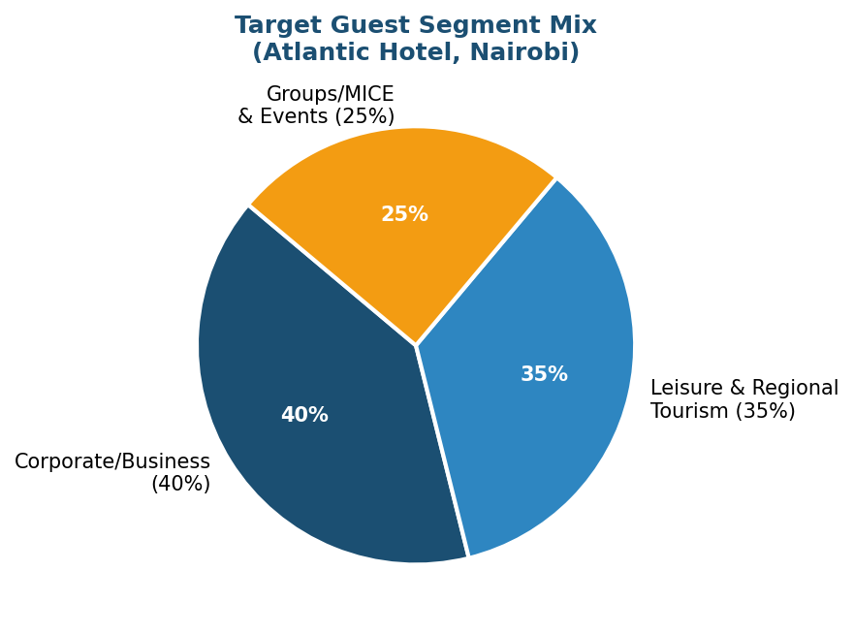

3.3 Competitive Landscape
The mid-market segment in Nairobi features moderate competition, combining international branded chains and independent properties.
Key competitive dimensions include: location (airport proximity or CBD), service reliability, competitive corporate pricing, and meeting room capacity.
Competitor Type | Positioning | Typical ADR Range | Competitive Threat
International Mid-Scale Chain | Consistent quality, loyalty programmes | USD 80–110 | High — direct competition
Independent Mid-Market Hotel | Local character, flexible pricing | USD 60–90 | Medium — less consistent service
International Economy Chain | Price leadership, standardised product | USD 50–75 | Medium — different value proposition
Serviced Apartments | Long-stay focus, kitchen facilities | USD 70–100 equiv./night | Low–Medium — different stay pattern
Atlantic Hotel (Proposed) | Corporate-focused mid-market at accessible price | USD ██–██ (redacted) | —

3.4 Revenue Assumptions
Parameter | Year 1 | Year 3 | Stabilisation (Y5)
Average Daily Rate (ADR) | USD ██ (redacted) | USD ██ (redacted) | USD ██ (redacted)
Occupancy Rate | 55% | 65% | 70%
RevPAR (indicative) | USD ~47 (redacted) | USD ~57 (redacted) | USD ~65 (redacted)
Room Revenue | USD 2,0██,███ | USD 2,5██,███ | USD 3,2██,███
F&B Revenue | ~12% of room revenue | ~15% of room revenue | ~18% of room revenue
Total Revenue | USD 2,1██,███ | USD 2,7██,███ | USD 4,1██,███

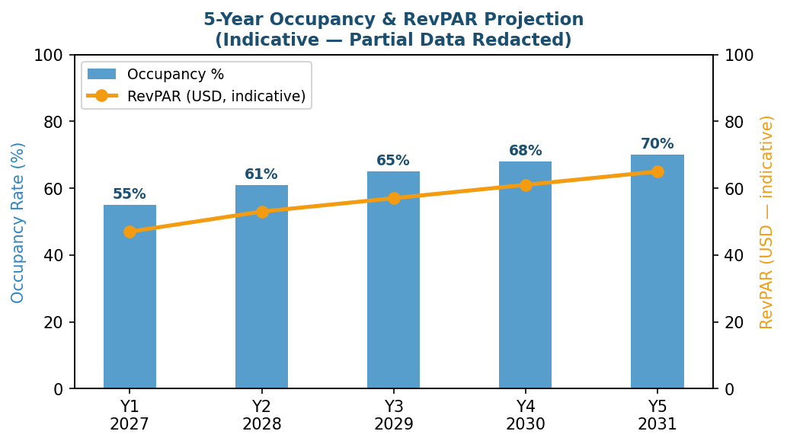

4. Technical & Operational Feasibility
4.1 Site Assessment
Site Option | Location | Advantages | Risks
Site A (Airport Corridor) | Near JKIA — ~15 km from CBD | Airport transfer demand; logistics hub proximity; land available | Traffic congestion; less walkable for leisure
Site B (Business District) | Westlands / Upper Hill / CBD | Corporate demand from adjacent offices; F&B footfall; embassy proximity | Higher land/rent cost; construction complexity

4.2 Utilities & Infrastructure
Utility | Status | Requirement | Backup / Mitigation
Electricity (Kenya Power) | Available in both catchments | Continuous supply for hotel operations | Diesel generator backup (mandatory); UPS for critical systems
Water Supply | Generally available; capacity confirmation needed | High-volume hotel use | Water storage tanks; borehole option
Telecoms / IT | Fibre available in target areas | High-speed internet | Dual ISP redundancy
Sewage / Waste | Municipal network in target areas | Standard sewage and solid waste | Waste management plan required for permits

4.3 Key Equipment & Lead Times
Equipment Category | Key Items | Est. Lead Time | Sourcing
HVAC Systems | Central cooling/heating for all rooms and public areas | 10–14 weeks | Imported (Asia/Europe)
Commercial Kitchen | Cooking lines, refrigeration, dishwashing | 8–12 weeks | Imported/regional
Laundry Equipment | Commercial washers, dryers, ironing units | 8–10 weeks | Imported
Elevators | 2–3 passenger lifts + 1 service lift | 12–16 weeks | Imported
FF&E | Beds, seating, bathroom fittings, lighting | 6–8 weeks | Local/imported mix
IT Systems (PMS, POS, CCTV) | Opera PMS, surveillance cameras, electronic locking | 4–6 weeks | Regional suppliers
4.4 Implementation Timeline
Phase | Key Activities | Duration | Target Schedule
Phase 1 – Pre-Construction | Regulatory approvals, permits, site finalisation, design | 8–12 weeks | Q3 2026 – Q4 2026
Phase 2 – Construction & Fit-Out | Civil works, MEP, FF&E installation, IT setup | 16–20 weeks | Q1 2027 – Q2 2027
Phase 3 – Procurement | Equipment orders, logistics, customs clearance | Parallel to Phase 2 | Q1 2027 – Q2 2027
Phase 4 – Staffing & Training | GM + HODs recruited; staff induction & training | 6–8 weeks | Q2 2027 – Q3 2027
Phase 5 – Soft Opening | Trial opening, system testing, pre-sales activation | 4–6 weeks | Q4 2027
Phase 6 – Full Commercial Opening | Marketing launch, OTA activation, corporate contracts | — | Target: Q1 2028
5. Management & Organisational Structure
─────────────────────────────────────────────────────────────────────────────────────────────────────────────
5.1 Ownership & Delivery Model
The recommended model is direct property ownership (lease or purchase — determined upon site selection) combined with a specialist local hotel management company for day-to-day operations.
This structure achieves a balance between asset control and operational expertise.
5.2 Proposed Organisational Structure
Board of Directors / Owners General Manager Department Heads:
• Front Office & Reservations • Food & Beverage • Housekeeping • Sales & Marketing • Finance & Accounting • Engineering & Maintenance • Human Resources
5.3 Staffing Plan
Department | Headcount (at Stabilisation) | Key Roles | Est. Monthly Salary Range (USD)
General Management | 1–2 | General Manager, Executive Assistant | 3,500 – 6,000
Front Office | 10–12 | Receptionists, Concierge, Night Auditor | 400 – 700
Food & Beverage | 15–18 | F&B Manager, Chef, Waitstaff, Kitchen Crew | 350 – 1,200
Housekeeping | 12–15 | Executive Housekeeper, Room Attendants | 300 – 600
Sales & Marketing | 4–6 | Sales Manager, Reservations, Digital Marketing | 600 – 1,500
Finance & Accounting | 3–4 | Finance Manager, Accounts, Night Auditor | 600 – 1,500
Engineering & Maintenance | 5–6 | Chief Engineer, Maintenance Technicians | 400 – 900
HR & Administration | 2–3 | HR Officer, Administrative Staff | 400 – 800
Security | 5–6 | Security Supervisor, Guards (24-hour shifts) | 300 – 500
Total (Approx.) | ~65 FTE | — | —

6. Financial Feasibility
──────────────────────────────────────────────────────────────────────────────────────────────────────────────
6.1 Capital Expenditure (CAPEX)
CAPEX Line Item | Indicative Cost (USD) | Notes
Land Lease / Acquisition | ███,███ – 8██,███ | Location-dependent; lease preferred for cash-flow efficiency
Civil & Structural Construction | 1,2██,███ | Includes foundations, structure, roofing
Interior Fit-Out | 4██,███ | Rooms, lobby, F&B, corridors
MEP (Mechanical, Electrical & Plumbing) | 3██,███ | HVAC, electrical, plumbing, fire suppression
FF&E (Furniture, Fixtures & Equipment) | 2██,███ | All room and public area furniture
Commercial Kitchen Equipment | 8█,███ | Full kitchen line for restaurant and room service
Laundry Equipment | 4█,███ | Commercial grade
IT Systems | 8█,███ | Includes installation and licensing
Pre-Opening Expenses | 7█,███ | Marketing, recruitment, training, soft launch
Working Capital Reserve | 1██,███ | 3-month operating expense buffer
Contingency (8% of hard costs) | ~2██,███ | Recommended reserve
Total CAPEX (Indicative) | USD 3,2██,███ | Rounded — actual total redacted

6.2 Operating Expenditure (OPEX) — Annual
OPEX Line Item | Year 1 (USD) | Year 3 (USD) | Year 5 (USD)
Staff Costs | 5██,███ | 6██,███ | 7██,███
F&B Cost of Sales | ~30% of F&B revenue | ~30% of F&B revenue | ~28% of F&B revenue
Utilities (Energy, Water, Gas) | 9█,███ | 11█,███ | 13█,███
Sales, Marketing & OTA Commissions | 12█,███ | 16█,███ | 20█,███
Property Maintenance & Repairs | 5█,███ | 7█,███ | 9█,███
IT & Systems Maintenance | 2█,███ | 3█,███ | 4█,███
Insurance | 2█,███ | 2█,███ | 3█,███
General & Admin (Legal, Accounting) | 8█,███ | 9█,███ | 11█,███
Depreciation & Amortisation | 1██,███ | 1██,███ | 1██,███
Loan Interest (if applicable) | 1██,███ | 9█,███ | 5█,███
Total OPEX (Indicative) | USD 1,2██,███ | USD 1,5██,███ | USD 1,9██,███

6.3 5-Year Financial Projections (Indicative)
KPI | Y1 (2027) | Y2 (2028) | Y3 (2029) | Y4 (2030) | Y5 (2031)
Occupancy Rate | 55% | 61% | 65% | 68% | 70%
Total Revenue (USD M) | ~2.1█ | ~2.7█ | ~3.2█ | ~3.7█ | ~4.1█
Total OpEx (USD M) | ~1.87█ | ~2.17█ | ~2.35█ | ~2.55█ | ~2.65█
EBITDA (USD M) | ~0.23█ | ~0.53█ | ~0.85█ | ~1.15█ | ~1.45█
EBITDA Margin | ~11% | ~19% | ~27% | ~31% | ~35%
Net Profit / (Loss) | (0.1█) | 0.1█ | 0.5█ | 0.8█ | 1.1█

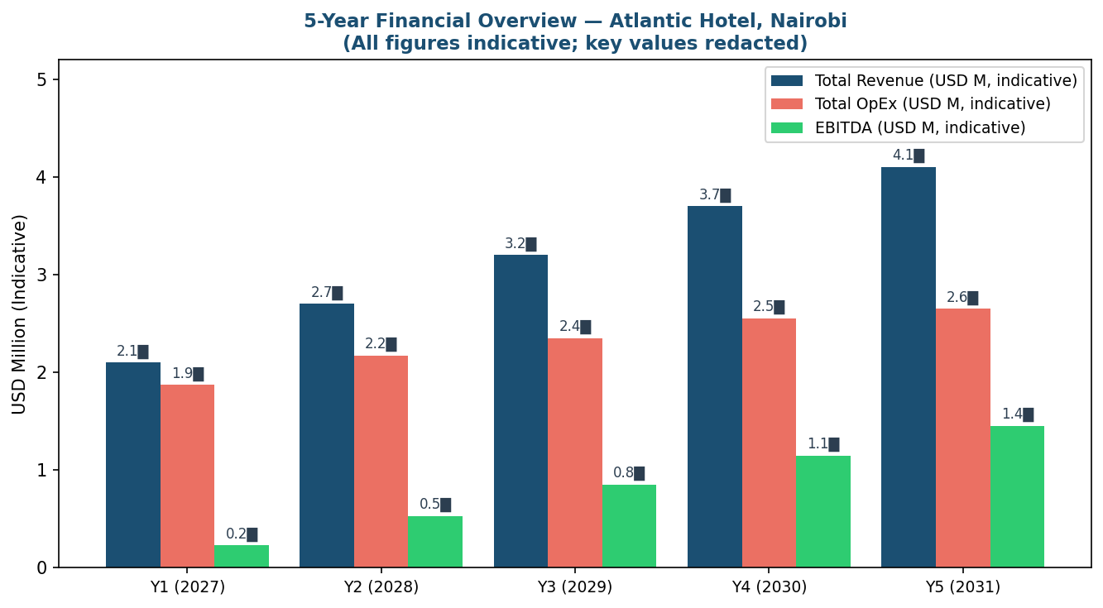
6.4 Break-Even Analysis
Assuming an indicative ADR and a variable cost per occupied room, the break-even occupancy rate is approximately 48% of total capacity on an annualised basis. With Year 1 occupancy projected at 55%, the property is designed to exceed break-even in its first full year of operation, subject to confirmation of CAPEX and cost assumptions in the full feasibility stage.
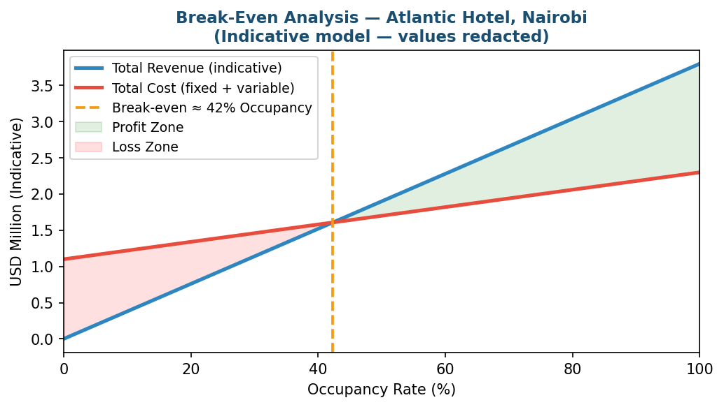

6.5 Key Return Metrics
Metric | Indicative Result | Basis
NPV @ 10% Discount Rate | Positive (USD 4██,███) | 5-year base-case model; actual figure redacted
Internal Rate of Return (IRR) | ~18%–23% range | Scenario-dependent; to be confirmed in full model
Payback Period | ~3.5 years | Base case; range 3.2–4.5 years across scenarios
Gross Profit Margin (Year 1) | ~40% | After direct room and F&B costs
EBITDA Margin (Stabilisation Y5) | ~35% | Indicative, pre-depreciation and interest
Return on Equity (Year 5) | ~██% | Equity-share dependent; actual redacted

7. Sensitivity Analysis
──────────────────────────────────────────────────────────────────────────────────────────────────────────────
Three scenarios were tested to evaluate project robustness against variations in key variables. Actual financial outputs are redacted; directional findings only are presented.
Scenario | Key Assumptions | Payback Period | NPV @10% | IRR
Pessimistic | Revenue -15%, costs +10%; Y1 occupancy 45% | ~5.0–5.5 years | Negative within Y5 window | ~██%
Base Case | Revenue per forecast; stable costs; Y1 occupancy 55% | ~3.5 years | Positive (USD 4██,███) | ~18–23%
Optimistic | Revenue +10%, costs -5%; Y1 occupancy 60% | ~2.8 years | Positive (USD 7██,███) | ~23–28%

Key Variable Sensitivities: Occupancy rate and ADR are the highest-impact drivers on NPV; NPV declines by ~██% for every 5% drop in Year 1 occupancy; a 10% CAPEX increase extends payback by ~0.5–0.8 years. Actual figures are redacted — to be completed in the full model.

8. Financing & Capital Structure
──────────────────────────────────────────────────────────────────────────────────────────────────────────────
The proposed financing mix balances equity returns and debt leverage while maintaining a comfortable debt service coverage ratio (DSCR). Final terms depend on lender appetite and investor profile.
Tranche | Amount (Indicative) | Share | Notes
Equity | USD 1,28█,███ | 40% | Founding investor / development partner
Senior Debt (Term Loan) | USD 1,92█,███ | 60% | 7-year tenor; indicative rate 8.5% p.a.
Total | USD 3,2██,███ | 100% | Matches indicative CAPEX

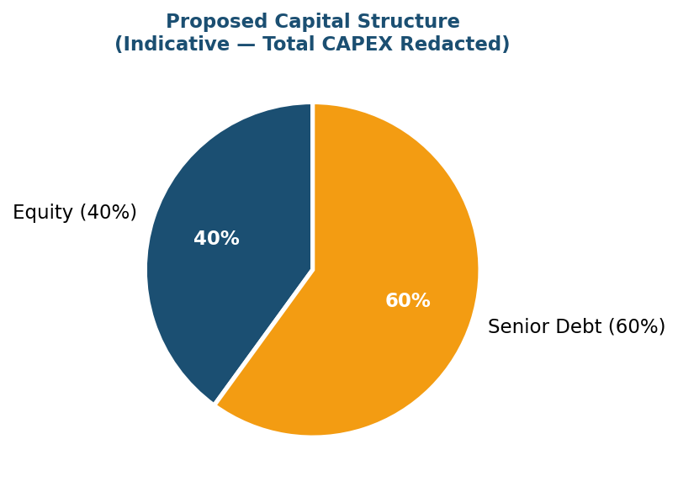
8.1 Indicative Debt Terms
Term | Indicative Value | Commentary
Loan Amount | USD 1,92█,███ | 60% of total CAPEX; actual cells redacted
Tenor | 7 years | Typical for East African hospitality project finance
Interest Rate | 8.5% p.a. (variable reference + spread) | To be confirmed with lender
Repayment | Equal monthly instalments after 12-month grace period | —
DSCR Covenant | >1.25× minimum | Standard covenant; comfortable in base case
Security | Charge over property/lease and hotel assets | —

9. Risk Assessment & Mitigation
──────────────────────────────────────────────────────────────────────────────────────────────────────────────
Risks are rated on a 5×5 matrix (Likelihood × Impact). Score ≥12 = High, 6–11 = Medium, <6 = Low.
Risk | Category | Likelihood  (1–5) | Impact  (1–5) | Score | Mitigation Action
Regulatory / Permit Delays | Legal | 3 | 4 | 12 — High | Engage local legal advisor early; 4-week schedule buffer
CAPEX Cost Inflation (imported equipment) | Financial | 3 | 4 | 12 — High | Fixed-price contracts; early ordering; 8% contingency reserve
Lower-than-Forecast Occupancy/ADR | Market | 3 | 3 | 9 — Med | Pre-signed corporate contracts; segment diversification; dynamic pricing
Currency Volatility (KES/USD) | Financial | 3 | 3 | 9 — Med | USD-denominated revenues where possible; hedge key exposures
Management & Staff Availability | HR | 2 | 4 | 8 — Med | Early GM recruitment; partner with local hospitality training institutes
Utility Supply Disruptions | Operational | 3 | 3 | 9 — Med | Backup generator; water storage; SLA with utility providers
Competitive Supply Increase | Market | 2 | 3 | 6 — Med | Distinctive positioning; loyalty and corporate programmes
Construction Delay / Contractor Risk | Operational | 3 | 3 | 9 — Med | Fixed-price contract; liquidated damages; experienced local contractor
Geopolitical / Security Events | Country Risk | 2 | 4 | 8 — Med | Comprehensive insurance; security plan; crisis management protocol
Interest Rate Rise | Financial | 2 | 3 | 6 — Med | Fix rate if possible; stress test at +200bps

9.1 Contingency Plan
Action | Detail
CAPEX Reserve | 8% of hard construction costs (~USD 2██,███)
Stage-Gate Investment Framework | Board approval at end of Phase 1 before releasing Phase 2 capital
Supplier Shortlist | Minimum 3 qualified suppliers per major equipment category
Minimum Occupancy Covenant | Review and action plan if rolling monthly occupancy falls below 45% for 3 consecutive months

10. Legal & Regulatory Framework
──────────────────────────────────────────────────────────────────────────────────────────────────────────────
The project will be structured as a Private Limited Company registered under the Kenyan Companies Act. No prohibitive regulatory barriers have been identified. Standard hotel licensing and hospitality sector approvals apply.
Requirement | Issuing Authority | Status | Estimated Timeline
Company Registration | Registrar of Companies (Kenya) | Pending | 2–4 weeks
Investment Certificate | Kenya Investment Authority (KenInvest) | Pending | 4–6 weeks
Planning / Development Permit | County Government / NEMA | Pending (site-specific) | 8–12 weeks
Hotel Operating Licence | Tourism Regulatory Authority (TRA) | Pending | 6–8 weeks
Fire Safety Certificate | National Construction Authority / Fire Dept. | Pending | Post-construction
Health & Safety Permit | Ministry of Health / County | Pending | Post-construction
Food Handler Licences (F&B) | County Public Health Officer | Pending | Post-construction
Liquor Licence (if applicable) | Alcoholic Drinks Control Board | TBD | 4–8 weeks
Data Protection Registration | Office of the Data Protection Commissioner | Pending | 2–4 weeks

11. Environmental & Social Considerations
──────────────────────────────────────────────────────────────────────────────────────────────────────────────
A full Environmental Impact Assessment (EIA) is required for this project and is out of scope for this sample. The following considerations have been identified as material and should be addressed in the full feasibility and EIA phases.
ESG Dimension | Consideration | KPI / Target
Employment & Livelihoods | ~65 direct FTE + 120–180 indirect jobs | Jobs created by opening date
Local Procurement | Target ≥60% of F&B supplies and non-technical materials from local/regional suppliers | % of local spend
Energy Efficiency | LED lighting throughout; energy management system; solar water heating considered | Energy intensity per occupied room vs. benchmark
Water Management | Water-saving fixtures; grey water recycling for irrigation where feasible | Water consumption per guest night
Waste Management | Waste segregation; F&B waste composting; single-use plastics reduction | % waste to landfill
Community CSR | Hospitality training programme for local youth; community event sponsorship (TBD) | Training hours; USD community investment value
Health & Safety | Full compliance with Kenyan H&S regulations; employee wellness programme | Lost-time injury rate

12. Conclusions & Recommendations
──────────────────────────────────────────────────────────────────────────────────────────────────────────────
12.1 Ur-Serv Recommendation
Based on the preliminary analysis conducted, Ur-Serv Business Advisory finds that the Atlantic Hospitality Hotel project is directionally viable under base-case assumptions. The market opportunity is real and growing, the financial model is positive at break-even occupancy levels achievable in Year 1, and the identified risks are manageable with appropriate mitigation measures. Ur-Serv recommends proceeding to a full feasibility study with primary and confirmed data.
12.2 Immediate Next Steps
# | Action | Owner | Timeline
1 | Approve full feasibility study scope and budget | Client / Investor | Immediate
2 | Commission primary market research (client interviews, corporate demand survey) | Ur-Serv / Research Firm | Week 1–3
3 | Obtain formal CAPEX quotes from 3+ contractors and key equipment suppliers | Project Developer | Week 1–4
4 | Engage Kenyan legal/regulatory advisor to confirm permits and incentives | Client | Week 1–2
5 | Identify and evaluate 2–3 candidate sites; commission land surveys | Developer / Ur-Serv | Week 2–5
6 | Negotiate with lending institution / DFI for indicative term sheet | Client / CFO | Week 3–6
7 | Identify and engage with potential hotel management partners | Client | Week 4–8
8 | Ur-Serv to deliver full report with unredacted figures | Ur-Serv | Week 4–6 (from kick-off)

Appendices
──────────────────────────────────────────────────────────────────────────────────────────────────────────────
Appendix | Title | Status
A | Detailed Income Statement, Cash Flow & Balance Sheet — 5-Year Model | Pending — to be completed in full feasibility stage
B | Full Sensitivity Matrix & Scenario Analysis | Pending — figures to be unredacted
C | Detailed Gantt Chart (Project Implementation) | Draft available — to be updated post site selection
D | Supplier Quotations & Technical Datasheets | Pending — formal quotes required
E | Primary Market Research Data & Interview Summaries | Pending — to be commissioned
F | Site Evaluation Comparison Matrix | Pending — post site survey
G | Environmental Impact Assessment Summary (EIA) | Pending — post site selection
H | Legal & Regulatory Compliance Checklist (Kenya) | Draft available from Ur-Serv
I | Data Sources & References | See below

Appendix I — Key Data Sources & References
• Hotel.Report — Sub-Saharan Africa ADR growth data, 2024: ~19% growth (2023–2024); Nairobi all-property average ~USD 124.
• Knight Frank — Kenya Market Update Mid-Year 2025: Hospitality sector showing sustained recovery and increasing investment confidence.
• Cytonn Investments — Nairobi Serviced Apartments Report, 2025.
• Tourism Regulatory Authority of Kenya (TRA) — Regulatory framework and hotel licensing conditions.
• National Construction Authority of Kenya (NCA) — Building permit requirements and procedures.
• Ur-Serv Business Advisory — Internal MEA Hospitality Benchmarking Database, 2024–2026. www.ur-serv.com
• World Bank — Kenya Economic Update, 2025 (GDP growth, FX, investment climate).
• MWAKILISHI / Frontier Africa Reports — Nairobi hospitality sector recovery outlook, August 2025.
• Source Strategies — Mid-scale hotel feasibility study model, 2024.
• feasibility-studies.com — Feasibility study framework, section structure, and financial modelling best practices.

──────────────────────────────────────────────────────────────────────────────────────────────────────────────
Confidentiality Notice: This document is a sample feasibility study prepared by Ur-Serv Business Advisory for planning and discussion purposes only. Financial figures are indicative and partially redacted (shown as ██) and must be replaced with actual project data and a full financial model before any investment commitment.
This document does not constitute investment, legal, or financial advice. CONFIDENTIAL — For internal use by the intended recipient only. © 2026 Ur-Serv Business Advisory. All rights reserved. www.feasibility-studies.com | support@ur-serv.com

